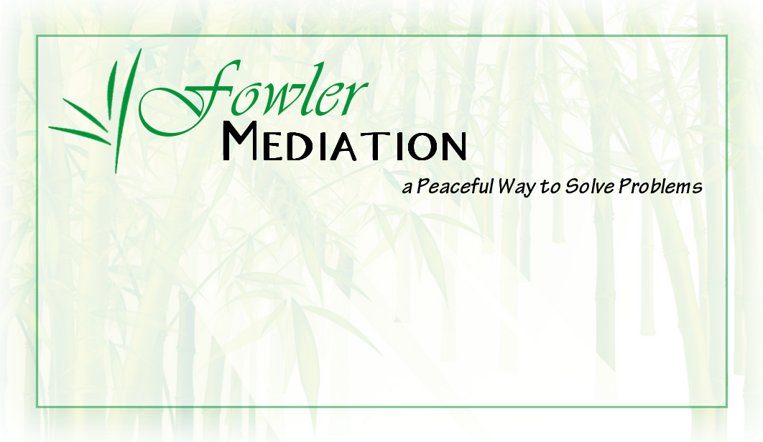

**Basic Mediation Training**

*5-day, 5-step program that*

*Teaches participants how to*

*Conduct a mediation, draft mediation forms, and*

*Understand key mediation values.*

*~ clarefowler.com ~*

Table of Contents

Session 1: Statements 7

1. Form Review 9

2. Prepare for Mediation 9

3. Write Mediator Statement 15

Session 2: Openings 24

1. Communication Triangle 27

2. Listening 28

3. Reframing 29

Session 3: Negotiation 37

1. Negotiation Agenda 37

2. Break the Escalation Momentum 37

3. Negotiation Tools 40

Session 4: Agreement 46

1. Identifying Exits 46

2. Develop Agreement 47

3. Define Role 49

Session 5: Resolution 54

1. Bring Resolution 54

2. Ethics 55

3. Mediation Styles 56

Dissertation Facts 66

Resources 70

Parties’ Opening Statement Notes 73

**Mediation Training Schedule**

SONAR: 6

Session 1: Statements 7

5 Set-up 7

5:15 Orientation 7

5:30-5:35 Maxim: Maslow Hierarchy 7

5:35-6 Schedule Review 8

6-6:10 Break 9

6:10-6:25 Mediation Prep and Forms 9

6:30-7:15 Confidentiality and Mediation Process 10

7:15-7:45 Dinner Break (Participants provide their own dinner) 11

7:45-8 Conflict Continuum and Conflict Path 11

Conflict Continuum: Alternative Dispute Resolution 11

Conflict Path 12

Agreement to Mediate and Confidentiality Form 13

8-8:05 Break 15

8:05-9 Develop Mediator Statement 15

Sample Mediator Statement 18

9-9:15 Break/Refine Statement 19

9:15-9:30 Ground Rules 19

9:30-10 Mediator Statements Review 19

Keys for S: Mediator Statement 21

Statement Notes Page 23

Session 2: Openings 24

Persian rug Ice-Breaker 24

8-8:15 Day 2 Job Ice-Breaker 24

8:15 Maxim Agathokakological 24

8:15-8:30 Mediation Goals 24

8:30-8:45 Role Play 3: Mediator Statement 24

8:45-9 Statement Phase Review 24

9-9:15 Review and Opening Statements 25

9:15-9:20 Personal Conflict and Break 26

9:30-9:45 Parties’ Opening 26

9:45-10:15 Opening Role-Play 26

Common Entrances: 27

10:15-11:15 Communication 27

11:15-11:30 Active Listening 28

11:30-12 Practice Active Listening 28

12-12:30 Lunch (Participants provide their own lunch) 28

12:30-12:35 Positions and Interests 28

12:35-1 Reframing 28

Reframing Examples 29

1-1:30 JJ Role-Play 7 and Break 29

1:30-2:30 Mediation Career Strategies 29

2:30-2:35: Break and review reframing keys 30

2:35 – 3 Note-Taking During Opening 30

Sample Note-Taking Form 30

3-3:30 Develop Mediation Agenda 30

3:30-4:05 Large-Group Role-Play 8 31

4:05-4:15 Break 31

4:15-4:30 Review Mediator Statement and Opening 31

4:30-4:45 Toolbox 31

4:45-5 Opening Phase Review 31

Keys for O: Parties’ Opening 33

Momentum Questions 33

Notes for Opening 36

Session 3: Negotiation 37

8-8:15 Review and Intro to Negotiation 37

8:15 Maxim: Firm Negotiation 37

8:15-9 Negotiation Agenda 37

9-9:15 Break 37

9:15-10:15 Negotiation – Moving from Escalation to Exit 37

10:15-10:25 Break 40

10:25-11 PON 4 Key Strategies 40

11-12 Historical, Current, and Future Interests 40

12-12:30 Lunch (Participants provide their own lunch) 40

12:30-1:30 Common Negotiation Tools 40

1:30-1:45 Break and review Negotiation Keys 41

1:45 – 2:15 Jedi Negotiation Tools 41

2:15-3:15 Large Group Role-Play 11 42

3:15-3:30 Break 42

3:30-4 Debrief Role-Play 42

4-4:30 Prisoners Dilemma 42

4:30-5 Review Negotiation Phase 43

Keys for N: Negotiation 44

Notes for Negotiation 45

Session 4: Agreement 46

8-8:30 Review 46

8:30 Maxim: My Contribution 46

8:30-9 Purpose of Agreement 46

9-9:45 Setting the Stage for Agreement 46

9:45-10 Break and review Agreement Keys 46

10-10:45 Develop Agreement 46

10:45-11 Difficulties of Agreement 47

11-11:45 Lunch 47

11:45-12:45 Agreement Specifics 47

12:45-1 Review SONAR and steps (refine statement and note-taking sheet) 48

Vacation Ice-Breaker 48

1-1:45 Small Group JJ Role-Play 12 48

1:45-2:30 Debrief Role-Play, Review Agreements 48

2:30-2:45 Break 48

2:45-3:15 Resistance to Agreement 48

3:15-4 Mediator’s Role 49

4-4:30 Importance of Precise Communication 49

4:30-5 Review Agreement Phase 49

Keys to A: Agreement 51

Impasse 52

Notes for Agreement 53

Session 5: Resolution 54

8-8:15 Review and Ice-Breaker 54

8:15 Maxim: Conflict is an Opportunity to Strengthen Relationships 54

8:15-8:45 Resolution 54

8:45-9 Break (review Dudley Resolution Keys) 55

9 – 9:45 Ethical Considerations and Review Questions 55

9:45-10 Break 56

10-12 Ethics 56

12-12:30 Lunch (Certificates provided by instructor on final day) 56

12:30-1:30 Finalize Forms 56

1:30 -2 Mediation Styles 56

2-2:15 Break 59

2:15-2:45 Next Steps 59

2:45-3 Resolution Questions 60

3-3:45 Large Group Role-Play HOA v. Foster Family 60

3:45-4:30 Mediation Issues/ Questions 60

4:30-5 Resolution Tools Developed 61

Keys to R: Resolution 62

Notes from Resolution 64

Dissertation Facts 66

Resources 70

SONAR 70

My Personal Conflict page 71

Toolbox 72

Example Mediation Notes 73

Glossary 74

Acknowledgements 75

Role-Play: Justin’s story 76

Role-Play: Julie’s Story 77

Large Group Role Play: Stop-sign 78

HOA (Home Owners Association) v. Fosters Role-Play 81

Evaluation 83

SONAR:

A 5-step mediation process for communicating with parties and moving toward resolution.

*Statement, Opening, Negotiation, Agreement, Resolution*

*Sonar* uses sound to communicate, send and receive information, understand what already exists, and assess and feel comfortable with the situation around us (*Statement and Opening).*

**Statement**: A Mediator’s statement, covering confidentiality and ground rules.

**Opening**: Parties’ Opening Statements, covering history and current argument.

*Sonar* provides information about clear paths, potential roadblocks to explore, and paints a picture of potential destinations (*Negotiation)*.

**Negotiation**: Determining scope of mediation, negotiating, & brainstorming options.

*Sonar* discovers hidden gems (*Agreement and Resolution)*.

**Agreement**: Drafting the parties’ mediated agreement.

**Resolution**: Closing the mediation for all involved.



# Session 1: Statements

*Sonar* uses sound to communicate, send and receive information, understand what already exists, and assess and feel comfortable with the situation around us.

### 5 Set-up

Trainer Introduction: Clare Fowler.

Peer mediator, then community mediation, then family, then workplace.

Master’s of Dispute Resolution

Doctorate of Organizational Leadership resolving workplace conflicts

Training resources and complete bio available at:

*www.ClareFowler.com CFowler@Mediate.com*

### 5:15 Orientation

Ice-Breaker: Name Trivia

*Why are you taking this course?*

Being a successful mediator is a mixture of understanding yourself and understanding your clients. Knowing your skills and knowing what mediation process you are successful with, helps you to be a better mediator.

Throughout this training we are going to learn more about you—what is your conflict resolution style, what mediation tools, are you comfortable with, what types of conflict make you uncomfortable, and what ground rules do you need in place to be effective. Add these keys to your toolbox: your strengths, your traits, etc.

### 5:30-5:35 Maxim: Maslow Hierarchy

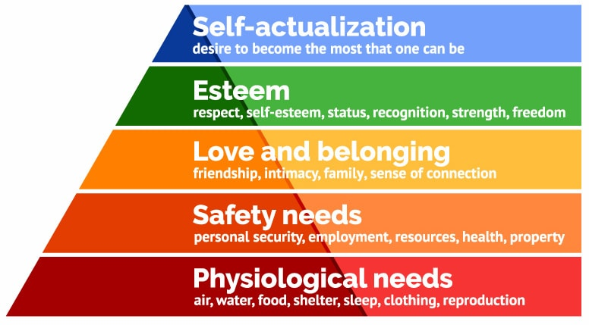

### 5:35-6 Schedule Review

**Schedule:**

**Learn in the morning, practice in the afternoon**

**SONAR**: This is your plan. Each day we will focus on one step:

**Statement, Opening, Negotiation, Agreement, Resolution.**

These 5 steps are your biggest tools. Become comfortable with them, and make them work for you. Sometimes you will spend more time on one step, sometimes you will change their order, sometimes you will repeat the process. These are *your* tools for resolving the dispute.

Today is Statement: This is the happy, “make you comfy” phase. We will examine the key pieces of a mediator statement, define the terms, write our own, and practice it. The point of this training is to become very familiar with each of these five steps. On the final day we will have a full-length role play. During the role play, you can review these 5 steps and make sure you are very comfortable with each of them.

**Goal of Statement = Happy**

Review:

**Binder**:

Dudley Keys (sample phrases)

Personal Conflict Path

Make notes in back

Dissertation Facts

Record Tools in Toolbox

Review, then create forms

Role-Plays (No peeking!)

**Schedule**:

Breaks every 1-1.5 hours

Learn in morning and practice in afternoon

Lunch is on your own. It is 30 minutes, assuming that you will eat/break for 30 and spend 15 minutes reviewing concepts from the morning, asking me questions, or reviewing the Dudley Keys we will use in the afternoon.

Role plays following each step, until complete mediation on last day

**Refine each step and become comfortable with it**

**Set-up for the week**

You will be assigned roles for the role plays—some of this includes secret information so please do not share it. This includes online participants!

You will also see your toolbox. Keep this one handy as we will be filling it out during the week.

Find your partner for 1st partner role plays.

## 1. Form Review

*Agreement to Mediate*: this is what parties will sign indicating that they are mediating of their own free will.

*Confidentiality Form*: this protects you and the clients. We will cover confidentiality more on day 5. The main thing is you want everyone to feel protected—know that whatever is said is confined to the mediation room. This means that you can’t call the papers with and neither can they.

*Mediator Statement*: this is what we will be creating today. Your mediator statement is what you will say at the beginning of the mediation to explain the process to your clients.

*Ground Rules*: this covers your expectations of behavior and communication during the mediation.

*Toolbox*: a mediator’s tools are what she is comfortable with, her techniques and phrases that keep things progressing. Mind you—especially in the beginning, better to be an expert in a couple of things; instead of familiar with all and an expert in none. I hope you pick things up from this training that will be of service to you—find your favorite technique, phrase, etc. Learn the others later—but simply become really good at one thing during this week.

*Mediation Agreement*: After the mediation, this is where you will write up the agreement that the parties have created.

*Evaluation Form*: we will be using mine as an example, helps to know what worked and where to improve.

*Center Forms*: supplied by a local Mediation Center or Courthouse.

Samples are available at http://clarefowler.com/pg26.cfm

### 6-6:10 Break

### 6:10-6:25 Mediation Prep and Forms

## 2. Prepare for Mediation

**Class Conflict: Justin v. Julie**

We are going to begin with an example of a case that I worked on about a decade ago. I chose this case because I learned so much from my mistakes, and I want to share those with you! It is also one of the few cases where I received complete agreement from both sides to share all of the details and the outcome of the case. I will still change all identifying information.

It involved a man who was suing a woman, saying he had given her a $1,500 loan and she never paid him back. We are going to be following this example everyday for the whole training.

In my example, Justin claimed he loaned Julie $1,500. Justin had filed a claim against Julie in Small Claims Court. The case was mandated to mediation, to try to settle without going to court. We will use this example to practice setting up for a mediation and your Mediator Statement.

**Setting the Stage**: https://www.youtube.com/watch?v=heUcre2d9wg – prep for mediation goes until 1:30.

**Mediation**: Process for dispute resolution in which an impartial person facilitates discussion and an agreement between parties. “Guiding people from conflict to peace.” “A cheaper faster way to solve problems than going to court.” “Helping my employees work through this issue as fast as possible so that they can get back to work.” “A way to tell my husband how much I hate him for dating my best friend and why I’m taking the house.”

**Write Definition of Mediation**: Now, take the next few minutes and write a 30 second elevator speech about mediation. Practice it. We will refine it over the week.

### 6:30-7:15 Confidentiality and Mediation Process

Zoom with Phyllis Pollack:

Confidentiality:

Confidentiality means: Communication that happened as part of the mediation cannot be disclosed to someone who was not present at the mediation, nor can the mediator be compelled to a court of law.

Why is it important?

Makes parties feel comfortable to discuss issues freely

Protects parties after mediation  
 Enables candor and trust (candor leads to successful mediation)

How is it protected? Confidentiality is explained in the beginning. Agreement is signed saying all parties understand that what happens is confidential. Mediation proceeds with mediator enforcing confidentiality during, caucus, and reminding parties of it at the close of mediation (regardless of written agreement).

UMA (2003):

*All communications, verbal and non-verbal, before, during or after that were part of mediation are protected. Includes notes, statements, and comments made by mediator, parties, attorneys, and third-parties.*

Exceptions:

Part of a public meeting  
Part of a government meeting to record laws

Limited confidentiality if other people are affected, typically stipulated in agreement

If mediator impartiality is questioned

If everyone waives their rights (mediator can testify in a sealed proceeding)

Disclosing that information can put parties at risk of a lawsuit for breach of contract.

**Mediation Process**

2 participants volunteer and help demonstrate the mediation set-up.

Chairs, table, white-board, water, forms, paper, and pens.

An additional volunteer helps vocalize the rationale for each step.

Invite people in and get settled

Welcome, Sign forms, Ground Rules, Mediator Statement, Opening by Parties, Negotiate, Agreement, Resolution

Welcome people (Justin and Julie)

Seating arrangement: start looking at me, then each other

Observe, Co-Mediate, Solo Mediate

Review Forms: Agreement to Mediate and Confidentiality (likely supplied by center,

I often put them on the table for parties to review while I am doing my Mediator Statement, then collect them before their Opening.

Notes: Write down names—everyone’s, including yours

Review SONAR process with parties

### 7:15-7:45 Dinner Break (Participants provide their own dinner)

During lunch, edit the attached Agreement to Mediate. Make it your own. Additional templates at: <http://www.clarefowler.com/pg26.cfm>

### 7:45-8 Conflict Continuum and Conflict Path

Write your personal conflict

Role-Play 2: Pair-up, review personal conflict. Discuss the entrance, escalation, and exit.

### Conflict Continuum: Alternative Dispute Resolution

Where does mediation stand in relation to other ways to resolve conflict?

(Image from Flat World Knowledge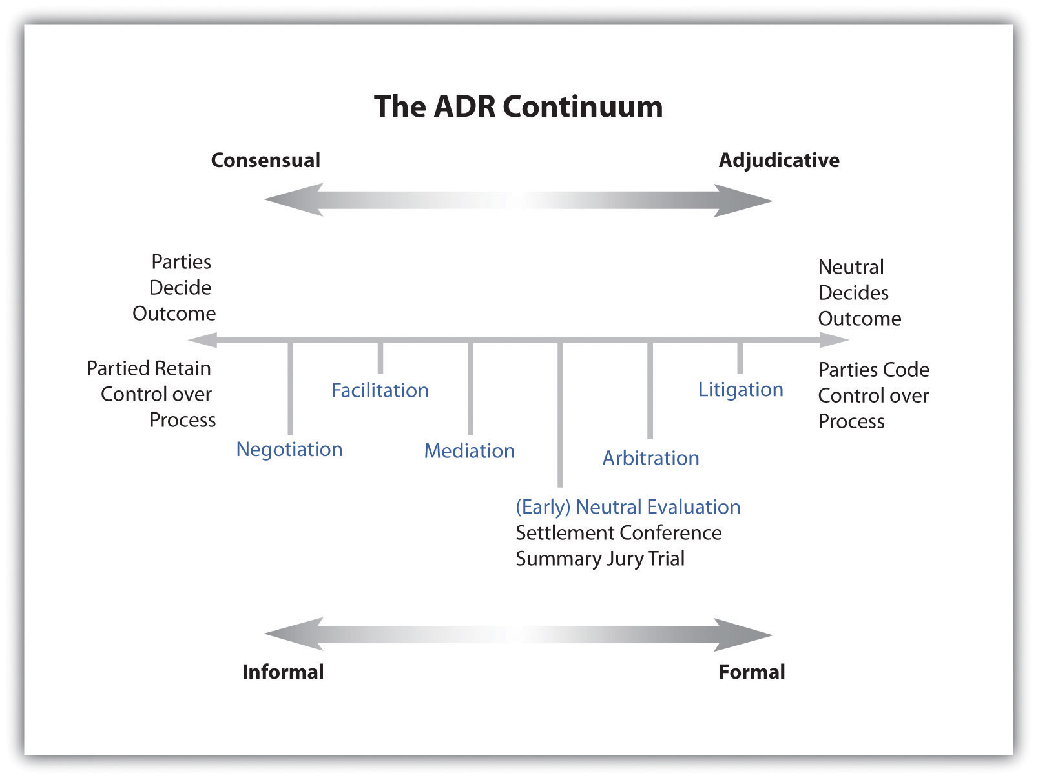

### Conflict Path

-Review dissertation data on conflict path, also at www.ClareFowler.com

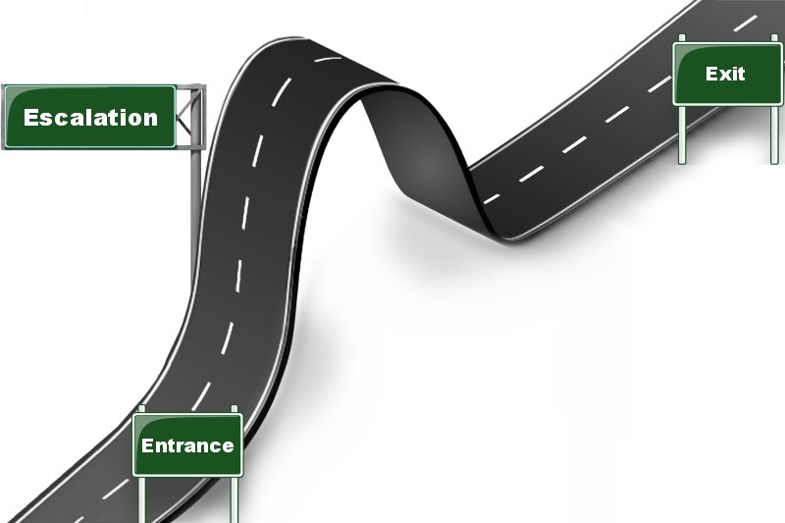

### Agreement to Mediate and Confidentiality Form

**Fowler Mediation**

**AGREEMENT TO MEDIATE**

This is an Agreement to enter into mediation with the intent of resolving workplace issues.

The participants and the mediator understand and agree as follows:

1. Nature of Mediation

The participants hereby appoint and retain Clare Fowler as mediator for their negotiations. The participants understand that mediation is an agreement-reaching process in which the mediator assists participants to reach agreement in a collaborative, consensual and informed manner. It is understood that the mediator has no power to decide disputed issues for the participants. The participants understand that the mediator's objective is to facilitate the participants themselves reaching their best agreement. The participants also understand that the mediator has an obligation to work on behalf of all participants and that the mediator cannot render individual legal advice to any participant and will not render therapy nor arbitrate within the mediation.

The participants also understand that mediation is not a substitute for independent legal advice.  The participants are encouraged to secure independent legal advice throughout the mediation process and are strongly advised to obtain independent legal review of any formal mediated Agreement before signing that Agreement. The mediator may come to require one or both participants to have their agreement reviewed by legal counsel to ensure that a participant is reaching a reasonably informed agreement. The participants agree that, even if the mediator is an attorney, the mediator will not serve any participant, nor all participants, as legal counsel, nor render individual legal advice in this mediation.

1. Scope of Mediation

The participants understand that it is for them, with the mediator's concurrence, to determine the scope of the mediation and this will be accomplished early in the mediation process.

1. Mediation is Voluntary

All participants here state their good faith intention to complete their mediation by an agreement. It is, however, understood that any participant may withdraw from or suspend the mediation process at any time, for any reason or no reason.

The participants also understand that the mediator may suspend or terminate the mediation, if the mediator feels that the mediation will lead to an unreasonable result, if the mediator feels that an impasse has been reached, or if the mediator determines that he or she can no long effectively perform his or her facilitative role.

1. Confidentiality

It is understood between the participants and the mediator that all mediation communications will be strictly confidential. Mediation discussions, be they in person, on the phone, by email, text or by any other communication modality, any draft resolutions and any unsigned mediated Agreements shall not be admissible in any court, administrative or other contested proceeding. Only a mediated Agreement signed by any participants may be so admissible. The participants further agree to not call the mediator to testify concerning the mediation nor to provide any materials from the mediation in any court or other contested proceeding between the participants. The mediation is considered by the participants and the mediator as settlement negotiations. All participants also understand and agree that the mediator may have private caucus meetings and discussions with any individual participant, in which case all such meetings and discussions shall be confidential between the mediator and the caucusing participant.

1. Mediator Impartiality and Neutrality

The participants understand that the mediator must remain impartial throughout and after the mediation process. Thus, the mediator will not champion the interests of any participant over another in the mediation nor in any court or other proceeding. The mediator is to be so “impartial” as to participant and “neutral” as to the results of the mediation. The mediator will seek to affirmatively reveal any operative biases and will disclose any and all prior contacts with the participants and their legal counsel.

1. Mediation Fees

The participants and the mediator agree that the fee for the mediator shall be $____ per hour for time spent with the participants and for time required to study documents, research issues, correspond, telephone call, prepare draft and final Agreements and do such other things as may be reasonably necessary to facilitate the participants reaching full Agreement.

DATED this __ day of ____, 2019

### 8-8:05 Break

### 8:05-9 Develop Mediator Statement

## 3. Write Mediator Statement

**Purpose of Statement: develop rapport,**

**Set the stage:** [**https://www.youtube.com/watch?v=YSnXNHUEodY**](https://www.youtube.com/watch?v=YSnXNHUEodY)

**Pass that excitement on to clients (Dwarves: heigh ho) https://www.youtube.co m/watch?v=HI0x0KYChq4**

**Definition of Mediation:**

**Choose Metaphor**

War – Cease fire

Poker – Bluff

Sports – Level playing field

Dance – Cooperative

Chasm – Bridge

Broken – Repair

**Cooking**: Bring out all ingredients, refine some, and put back what doesn’t work for this dish.

**Translator:** Different backgrounds create a different context for words. I’m here to translate what those words mean to each of you, and help you understand where the other one is coming from.

**Building a House**: Let’s decide together what structure will keep this house strong, and then you can work together to furnish the inside.

**Elements of a Mediator Statement**

*Participants read and explain each element. Take 2 minutes after each element for participants to draft their own.*

Mediator Statement: SCORVINO

S--SONAR

C--confidential

O--open to ideas

R--rules

V--voluntary

I--informal

N--non-binding

O—Omnipartial

**JAMS sample mediation:** [**http://www.mediate.com/articles/jamsvideo1.cfm**](http://www.mediate.com/articles/jamsvideo1.cfm)

* were the elements in there?

(These explanations are written informally to clearly and casually explain these terms to clients. Please come up with a casual definition that feels comfortable to you.)

**SONAR/ Mediation Process**: I will guide you through this process and help you to develop your agreement. (Statement, Opening, Negotiation, Agreement, Resolution). This is a **Party-Driven process**: you are large and in charge. I guide the process, you determine the agenda, you determine the agreement. I am a cheerleader, a coach, a trainer, referee, go-between, trouble-shooter.

**Confidential:** A secret, entrusted with confidence. Don’t share information with anyone outside of this room, “like Vegas—what happens in mediation stays in mediation”, protection so that you can trust me with your interests.

**Open to Ideas**: willing to consider a thought that you didn’t walk in here with. And **Open to Share**/**Good Faith**: comes from latin for Bona Fide—meaning in good faith, that parties will deal each other honestly, presuming they can fulfill their end of the bargain, supporting the other’s right to trust in the agreement, that no important information is held back, that you aren’t going to use this information to harm the other person.

**Rules:** Agree to Ground Rules: Create a comfortable environment. Speak Respectfully and Listen Respectfully.

**Voluntary**: Something done with free will, self-determination, because being here is better than avoiding this, you can leave if you need to, you have veto power

**Informal/Formal**: A formal process: if there is any law, criminal, or legal implication. Informal: fact-finding, see where people stand. Employers and courts often specify if it has to be a formal or an informal process.

**Non-Binding/Binding**: will this go on record with the courts/employers/unions or not? Technically a contract is binding if two people sign it, so some people argue that the process is always binding. I tell people that yes, it is a contract and so the courts can enforce it if need be.

**Omnipartial or** **Neutrality**: I am not an advocate/attorney/therapist/executioner. If I am hired by both of you, I have no conflict of interest. I am a guide, an **omnipartial** guide. (Ken Cloke’s term)

**Ground Rule Examples**

Don’t character assassinate

Don’t interrupt

No put-downs

We agree to call each other by first names

We agree to consider ideas that we didn’t come in here with

We agree to listen

We agree that we might need to try something new if we want to see a change

We will say if we disagree with something

We will request a break if we need it

We will request to speak to mediator privately if we have a question

If mediation does not produce an agreement, we will leave whatever offers and knowledge gained in mediation.

We agree to pause the conversation when anyone requests it.

After we have discussed past, we agree to move to focusing on future.

We will attack the problem not the person.

### Sample Mediator Statement

My name is Clare Fowler and I am your mediator. Thank you for participating in mediation.

Mediation is a process where a neutral person guides you through a conversation to hopefully reach an agreement.

Mediation is a **voluntary** process. You are here of your own free will because you are taking control to make this conflict better.

Mediation is **confidential**. That means when we are done mediating, I will not and by law cannot discuss the details of this mediation. It means that you are held to those same rules.

Mediation assumes you are acting in **good faith**. You are telling the truth, including all pertinent information, and you are negotiating to try to reach an agreement.

Mediation is a **neutral** process, meaning I do not take sides. I try to listen to both sides and advocate for both of your interests.

Mediation is a **party-driven** process—I have a template I like to follow, but if you need to go back and review something or move ahead then you both are the boss.

Mediation is an **informal** process, meaning we are currently resolving a dispute outside of the court’s eye.

Mediation is a **non-binding** process. This means that I can’t bind you to a decision that I make. Instead, all of you can choose if you come up with an agreement that you want to adhere to.

Mediation means that you are **open to compromise** and that you agree to our ground rules.

Mediation is a **5-step process**: it begins with my explanation, then I’ll want an explanation from each of you, then we will discuss those explanations, and then hopefully reach an agreement.

**Signed______________**

**Dated______**

### 9-9:15 Break/Refine Statement

**Statement:**

How do you describe these elements with your vocabulary?

Review Dudley Braun’s Keys and incorporate into your statement.

### 9:15-9:30 Ground Rules

Brainstorm ground rules for our training.

What will make us feel comfortable? What else do we need to include for a mediation?

Develop Ground Rules. This is what makes the room comfortable enough to be helpful.

**Comfortable Environment**:

No cell phones unless emergency

Heat

Bio breaks/bathrooms

First break

Parking meters

**Speak Respectfully:**

Don’t thunder (thunder and turtle)

Don’t name call (because it hurts, thus is counterproductive)

Don’t overpower (through intimidation or silence)

Be willing to compromise (hang the meat low enough so the dog can bite)

**Listen Respectfully:**

Don’t interrupt (Some people remember events as a ball of string. Interrupt and they need to start over. Confusing for the mediator. Hurtful. Builds walls.)

### 9:30-10 Mediator Statements Review

Why do we need a mediator statement?

Build rapport

Puts people at ease (mirror neurons)

Reinforces equality/diminishes power imbalances

Gain parties’ attention

Re-draft Mediator Statement

**Toolbox**

Every mediator has a toolbox. We will add to this toolbox daily. You don’t have to be an expert in every one—find what works for you.

Today we added:

Mediator Statement

Ground Rules

What else will you add?

**Statement Phase Tools Developed:**

Review Forms (Agreement to Mediate)

Prepare for Mediation (understanding what caused conflict)

Write Mediator Statement (30. Sec Definition of Mediation, Basics of Process, Ground Rules)

Understanding of SONAR

### Keys for S: Mediator Statement

This is a process in which the two of you have come together to present and discuss a problem or dispute that’s going on. Then you’ll have the opportunity to present and discuss solutions for resolving the matter.”

“A few ground rules are important to help the process flow smoothly: One person at a time speaking, no interrupting, no name-calling, no making faces or emitting rude sounds of disgust or disbelief. Basic common courtesy will help a lot. Agreed?”

“We’ll make progress more quickly if we take care to avoid ‘linguistic irritators’. OK?”

“Do you want to achieve an out-of-court settlement?”

“Do I have your commitment to listen to each other; work hard toward a resolution; and bargain in good faith? Good faith includes keeping to the truth about the facts.”

“Check whether you have whatever information you need to settle the case.”

“The final money terms and your success depends on taking into account the way the other party feels about how they’ve been treated during negotiation.”

“Although tangibles like the money settlement are important; intangibles such as pride, reputation and good will are very real and very important as you craft a resolution together.”

“You’re both competent to come to an agreement.”

“Today we’re not going to conduct this as a “contest” to be won or lost. That’s not what we’re about. Instead, we’re going to discover the “best voluntary solution”.

“Today is the day to look forward, not dwell on the past.”

“You work creatively toward finding a resolution that feels good or at least workable

and lets both parties leave satisfied or with an appealing solution.”

“I’m not going to try to solve your dispute or your problems. Your job is to figure out how to sufficiently take into account each other’s interests so you can craft a mutually satisfactory agreement.”

“Part of my role is to help you avoid common mistakes, such as:

- Insensitive or pugnacious remarks

- Guessing what the other party will do or find acceptable

- Getting too competitive toward winning instead of compromise

- Giving up too soon.”

“I’ll guide the process and you’re welcome to suggest process changes at any time.”

“I’ll be neutral but not passive. Hopefully I can point out things neither of you have thought much about.”

“What kinds of things do you want to happen or not happen in this process?”

“How would you like this to go?”

“We all want to be heard with complete attention. I encourage you to really listen to each other and avoid the temptation to anticipate the speaker’s endings. Keep up your focus on the speaker’s words, not on what you’re going to say next.”

“It’s particularly useful to ratchet up your active listening skills and listen intently to what’s beneath the words.”

“Listen for anything new; for something you didn’t know before.”

“Patience, flexibility, and self-determination are the keys of this process.”

“My job is not to tell you the answer. That’s for someone wearing a long black robe. I just help people figure out the puzzle pieces and how they might line up.”

“What works is: Courage and Compassion; Humor and Humility; Tolerance and Understanding.”

“We have the best chance of a good resolution if you both are able to talk together constructively, exploring and understanding each other’s interests and needs.”

“The way you get a solution is to cooperate with each other as you explore what might work for both of you.”

“Sharing interests and needs will assist you two in brainstorming options together.”

“The solution you create together doesn’t have to be what a judge would order.”

“I’m going to ask you to reflect back what interests and needs the other side expresses.”

“Conversation is a learning process where new helpful information will surface and be considered thoughtfully.”

“You may be adamant on one issue, but other issues may not be simply black or white.”

### Statement Notes Page

# Session 2: Openings

### Persian rug Ice-Breaker

~ Cleaning company washed $7,500 rug.

Interests:

* Wife, culture
* Cleaning company, reputation
* Husband, likes clean house

Who do you start with in mediation and why?

What outcomes do you envision?

### 8-8:15 Day 2 Job Ice-Breaker

**Communication**

Ice-Breaker: Job—your name and what you love about your job.

### 8:15 Maxim Agathokakological

8:15-8:30 Mediation GoalsReview what you have learned yesterdat about mediation

What elements of SONAR is the mediation statement designed to do? Spread peace and happiness to clients: like a good host, <https://www.youtube.com/watch?v=bk7jPNcVrJI>, not necessarily to share information

Do you want to make any changes to your definition of mediation?

What would you describe now as your main purpose in mediating?

Review your statement—does your language support that purpose?

Look at your Agreement to Mediate and Confidentiality Form—is this giving information and establishing rapport?

### 8:30-8:45 Role Play 3: Mediator Statement

Practice with your partner. One person is the mediator and that the other person coming into your office is Justin or Julie and you are giving them your Mediator Statement.

### 8:45-9 Statement Phase Review

**Mediation is like catching amazing people at their worst:**



### 9-9:15 Review and Opening Statements

Questions from yesterday?

**Review S**

**S—Mediator Statement. Happy phase** (like a minion). *Sets the stage, encourages the casual but trusting tone you need. Be mentally behind them, pulling them back a bit*

Look at an Agreement to Mediate form and listen to a Mediator Statement—providing information and making people happy?

**Opening Phase**

SONAR uses sound to communicate, send and receive information, and understand the situation around us. Letting people communicate shows us what paths we need to go down.

**O—Parties Opening. Digging phase** (Shoveling).  *Today is more of the theory of conflict and giving you an understanding of your clients’ reaction and role in conflict. This will help you to get them to a place where they want to negotiate. Be completely present, in accord with their emotions.*

**Know what you are looking for, but also be ready for the unexpected.**

**Goal of Opening = curiosity**

**Opening Statement**

SONAR: Today we are going to send out signals to encourage effective communication. The goal is to receive information about our clients.

A friend of mine Robert Benjamin told a story about his knee. He was hurt and the doctor gave him some Vicodin for it. When he went for his check-up the doctor kept saying does this hurt, is this ok? Robert kept saying yeah, everything’s fine. Because he couldn’t tell what hurt, where the problem was. *Allowing people to vent and express what really upsets them shows us what hurts.*

### 9:15-9:20 Personal Conflict and Break

## 9:20- 9:30 Personal Conflict: (Form of Communication)

What forms did you use to communicate about your personal conflict?

Review Dudley Braun’s keys for listening/opening.

Go around group and share different forms.

This is probably what your clients have done by the time they got into their conflict.

### 9:30-9:45 Parties’ Opening

**Parties’ Opening**

Story about Masseuse mediation

~how the opening quickly escalated

~I had to choose my words very carefully.

Deciding who goes first: begin alphabetically or strategically, then alternate throughout the rest of the mediation. Whatever your process, verbalize it and alternate it.

Ask them to tell their story by:

* Historical
* Catch-up to speed
* Chronological
* Highlight the main points
* Explain the recent tipping point
* Review any legal proceedings

**Media Clip: Dog role-play** <http://www.mediate.com/articles/communityroleplay.cfm>

### 9:45-10:15 Opening Role-Play

Taking Mediation Notes—minimal, only jot down issues.

<http://www.mediate.com/articles/WorkplaceTrainingVideo.cfm> workplace mediation

Role-Play 5: Partners pair up to listen to do JJ opening statements and take brief notes.

Identify the Entrance:

(<https://youtu.be/-KSryJXDpZo> – Lack of fairness)

### Common Entrances:

* Miscommunication
* Negative Intimacy
* Asphalt
* Grassroots Grumblings
* Death Rumblings
* Personal Space
* Lack of Clarity

### 10:15-11:15 Communication

## 1. Communication Triangle

Conflict Cougar: What happens?

1. Recognize: Physiological responses, instinctual
2. React: Window of Tolerance, physical: fight, flight, or freeze
3. Role: Superhero, Dragon, Victim. Mental. (Ken Cloke’s work, Moana clip) Describe each role. *Extra credit: How do you communicate with someone at each level?*

This means there are 3 levels built on top of the conflict that have to be taken down. Move through the 3 levels: “Taking Out the Garbage” Position > Interest > Value/Fear

Not Intuitive!! Most communicating is selfish, whereas mediation communicating is selfless!!

**3 Levels of Messages**—1) You are lazy! 2) I need help 3) I don’t want to be taken advantage of or I’m afraid I will fail (bottom level is often fear or a crossed value)

*What level is preferable to discuss in mediation?*

Interests v. Issues (and position on that issue)—iceberg, interest-based negotiation.

So what do we do?

**We show people how to communicate well, and they model our example. Communication Tips:** Using “I” Statements, look in eyes, non-verbal, silence, write notes, ask why.

Neuroplasticity: we can change! Good communication encourages better communication. Good conversation in a mediation can have long-lasting changes.

Increase our Window of Tolerance

### 11:15-11:30 Active Listening

## 2. Listening

Begin w/ Mediation trust fall video

<http://www.youtube.com/watch?v=wPOgvzVOQig>

(Message sent is often not message received)

To avoid that, we listen closely and ask careful questions.

**Active Listening**

Open-ended questions

Reading Between the Lines

Different than agreeing

Different than providing personal examples

Sorting Information

Firm digging:

<https://www.youtube.com/watch?v=HI0x0KYChq4>

Too fast and you will miss something

Too hard and you will break something

Too soft and you won’t make progress

Push gently into the pain. once you have found it, thank them, treat it as important, and move through.

### 11:30-12 Practice Active Listening

Partner exercise 6: One partner shares their side of their personal conflict. Truly listen for two minutes as they describe why the conflict was difficult for them. Partners can only ask open-ended questions. Be present, not strategic. Make eye contact. Use non-verbal encouragement.

Share how this was for you.

### 12-12:30 Lunch (Participants provide their own lunch)

### 12:30-12:35 Positions and Interests

Define positions and interests (like a caramel M&M): hard shiny shell protects gooey good stuff inside.

### 12:35-1 Reframing

<http://www.mediate.com/articles/videodefensiveness.cfm>

## 3. Reframing

(“Steaming Broccoli”)

Give a Justin and Julie example: She is so selfish!

Listen for emotions: He never called me.

Listen for hidden messages: He is so lazy.

**When do we reframe**:

Increases common ground: He never thinks about what the kids want. She never considers the kids’ summer vacation plans.

Detoxifies: I don’t ever want to do business with him again!

Move from positions to interests: I will not work with someone who is so forceful and disrespectful.

Phrase as a question: Do I understand…?

Remove always and never

Change he, zhe, and she pronouns to “we”

Reframe to reduce Power Imbalances: <https://vimeo.com/58051674> Nina Meierding excerpt, at [www.Mediate.com/University](http://www.Mediate.com/University) (1st 2 minutes)

### Reframing Examples

Intonation example:

I didn’t say the boss was a jerk.

Exploring Hidden Messages:

He’s too mean. (Thunder/Turtle Syndrome)

She’s a baby. (Baby/Bully Syndrome)

She’s crazy. (Turkey/Chicken Syndrome)

Reframing:

I can’t work with her.

She always manipulates the people around her.

He has been saying for weeks he will help me on this. He never does.

### 1-1:30 JJ Role-Play 7 and Break

JJ Role-Play w/ new partner: Review Statement, Opening, Active Listen, take basic notes, try to identify Escalations, Positions, Interests, and Reframe.

### 1:30-2:30 Mediation Career Strategies

Guest Speaker: Julie Gentrili Armbrust, <https://mediationnorthwest.com/> Author of [Divorce Mediation in Oregon](https://mediationnorthwest.com/julies-book/)

### 2:30-2:35: Break and review reframing keys

### 2:35 – 3 Note-Taking During Opening

**Taking Notes During Opening:**

Identify interests through levels of feeling and messages. Interests will create agenda. Purpose of notes?

### Sample Note-Taking Form

Parties’ Opening Statement

|  |  |  |  |  |
| --- | --- | --- | --- | --- |
| **Alex Interests** | | **Clare**  **Notes** | **Susan Interests** | |
| I | Thinks she’s doesn’t work hard enough |  | ? | Hasn’t received any management support |
| ? | Wishes she would do more work |  | I | Applied for trainings, but always told she was needed in her current position |
|  | Wishes she could work faster |  | C | Doesn’t like her secretary |
|  | Wants to have her move up be a boss | A |  | She wants to move up to be a boss |
| ? | She was hired to move into management |  |  | Admits she got frustrated and “gave up” |
| O | Willing to give her paid time-off for a 2-day mngmt seminar |  | O | Would like to try to be a Project Manager to show them she’s ready to recommit |
|  |  |  |  |  |
|  |  |  |  |  |
|  |  |  |  |  |

I: Interest

?: Review this

O: Offer

A: Potential Agreement

C: Clipboard

### 3-3:30 Develop Mediation Agenda

(Adjust agenda as necessary)

1) Clarifying original job responsibilities and goals

4) Discussing roadblocks to past trainings

2) Understanding Susan’s potential as a manager

3) Acknowledgement of mis-steps

6) Future plans:

Trainings

Project Manager

Promotion?

5) Increased workload

Note-taking form—brief intro – Form Circled I

Identifying Interests

These “I’s” will create their agenda (Step 3)

**Instructor-led Role Play 7**: Practice—Trainer shows story, students take notes

<http://www.youtube.com/watch?v=Sm4bG3B9GBQ> begin at 1—landlord tenant mediation with caucus

### 3:30-4:05 Large-Group Role-Play 8

**Large-Group: Personal Practice w/ a Student’s Personal Conflict**

Someone does opening; we reframe as a group. We identify feelings, interests, messages, and roles.

### 4:05-4:15 Break

### 4:15-4:30 Review Mediator Statement and Opening

Watch :

<https://www.youtube.com/watch?v=9Oji5dxQemQ>

* Did they check everything off for their mediator statement?
* What ground rules?
* Take notes.
* What is it like having a comediator?

### 4:30-4:45 Toolbox

Debrief

Importance of reframing

Reframing Key you selected

Toolbox: what will you use most?

Any changes to your Mediator Statement?

Note-Taking form

Identifying Interests

### 4:45-5 Opening Phase Review

Opening Phase Tools Developed

Listening

Communication Triangle

Reframing

Conflict Cougar:

Recognize

React

Role

Creates 3 levels of messages that must be worked through.

### Keys for O: Parties’ Opening

### Momentum Questions

Can you tell me how you met?

What was it like when you began working together?

Describe how things have changed this last year.

Can you say more about that?

Is that right?

Have I understood you?

Tell me what I’m missing:

Is this the right word?

Describe your ideal working relationship five years from now.

If this hadn’t happened, what would your life be like right now?

Imagine you could go back and say what you really meant.

What would you have done if you were in her shoes?

So these three issues are the most important, and we should probably begin with this one. Is that correct?

Before we start, I’d like to check on how well each of you understand the other’s point of view. So in your own words, ______, please tell us ______’s point of view.” [Then:

“How well does that express your POV? Any changes or additions?”]

“We want to have a discussion as fully informed as possible.”

“I’m going to ask each of you to listen carefully while the other party explains the essence of the dispute to me. Let them have their say without interruption. Agreed?

I’ll ask clarifying questions. Try to distill it down to what you want and what is the factual and legal basis for your claim. Okay?”

“To conserve your time, I’m going to ask you to summarize your perspective concisely and get us to the heart of the matter.”

“Could you please summarize the story from your viewpoint? Please tell me (briefly) what lead to this meeting?”

“How much is your claim?” [answer] “How did you arrive at that figure?”

“What are the main aspects of the claim? What problems do you want to solve?”

“What’s the rationale for the claim?”

“What is the factual or legal basis for your claim?”

“What have you got to go on? What sorts of writings support the claim?”

“What have you got to back it up?”

“As they say in the legal system: “The faintest writing beats the best memory.”

“Don’t be discouraged as you listen to the other side or as they listen to you.

Absolute truth is often an illusion because it’s the first victim of a conflict.”

“Do you have any more or stronger supporting statements?”

“Why should we believe that __________?”

“A court looks for a “preponderance of evidence” and then whether the evidence is “clear and convincing”. Tell us what you’ve got.”

“What documentation is there to justify ______?”

“What evidence is there that adds legitimacy to your assertions?”

“How are you going to meet certain burdens of proof?”

“Do you have any concerns, based on what you’ve seen and heard that you could sustain your burden of proof?”

“How does the situation look to you?”

“What is this dispute getting in the way of?”

“A commonly accepted test for evidence is: What would an unbiased critical person be likely to accept?”

“Is it okay with you that we pause here and hear from _______.””Let me share with you what I’ve heard. Please correct me if you hear anything wrong.”

“You indicated _____”

“One observation you made is _____”

“You are saying ______”

“It sounds like you’re telling me_____”

“You’re also telling me _____”

“I’m hearing _____”

“What I’m getting is __________”

“I think what I’m understanding is __________”

“To summarize, what you both seem to be saying is ______”

“And you have some concerns about ____”

“Is that accurate?”

“Is that right?”

“Have I heard you correctly?”

“I hear you. I understand.”

“Thank you ___. I think we all have a better sense of how you feel and what you are going through as ____.”

“It sounds like you’re saying you made some errors and you want the consequences to be over with sooner rather than later. Is that right?”

“What I’m hearing from both of you is a real interest in getting this resolved. With good faith collaboration that’s very possible. Working together you can do it.”

**Mutual Understanding**

“You’ll make the most progress toward resolution by making this a conversation where you demonstrate understanding of the other side’s interests while you express yours.”

“I’d like each of you to be open and receptive to the perspectives of the other person.”

“You can hold onto your story while opening your perspective to understand their story.”

“There’s always room for, and even a need for, a variety of perspectives.”

“A rival is just a stranger whose story hasn’t yet been heard.”

“I’d like you to tell me the other party’s point of view; just as if you were speaking for them.”

“Is there any more information you want from the other side?”

“If you took this to court, what would you realistically expect?”

“How sure are you what the court would decide?”

### Notes for Opening

# Session 3: Negotiation

### 8-8:15 Review and Intro to Negotiation

*Sonar provides information about of clear paths, potential roadblocks to explore, and paints a picture of potential destinations. –*

*Review Statement (Create happiness--host)*

*Review Opening (Create knowledge--digging)*

**Negotiation** *(Create value--panning for gold*)

**Goal = Show the Gold**

The purpose of negotiation is to act as the foreman—give directions, but let other people do the labor.

Ice-Breaker: 30 sec. Mediation Definition Review—go around room so people can read theirs.

### 8:15 Maxim: Firm Negotiation

### 8:15-9 Negotiation Agenda

## 1. Negotiation Agenda

Drafting an Agenda

Using an Agenda as a Tool—you can let parties decide order, help to agree on something little or you can decide order

Agreement on little issues v. Elephant in the room

Once the agenda has been created, parties can begin to negotiate.

**Who goes first?** [**http://www.youtube.com/watch?v=XEGy_asxL2U**](http://www.youtube.com/watch?v=XEGy_asxL2U) **How do they both keep their power and decide who puts down the first offer?**

**Group Car Negotiation to develop agenda together.**

### 9-9:15 Break

Review your personal conflict. Write down at least one agenda item from both sides.

### 9:15-10:15 Negotiation – Moving from Escalation to Exit

## 2. Break the Escalation Momentum

After Statement and Openings, ask people to turn toward each other.

Look at the Interests you identified and write them down into an agenda. Ask for confirmation.

As clients begin to negotiate, take notes. These notes will typically form their agreement.

Note-sheet: Interest, Offer, Question, Agreement, Clipboard

I, O, ?, A, C

If parties are stuck, name why and how they escalated to validate their experience. This helps them let go of their position and begin to exit.

Break the momentum!

As conflicts escalate, they gain momentum. We get swept up in the emotion of, and it becomes harder to find the exit.

**Common escalation steps**: Ingratiation, Persuasion, Silent Treatment, Shaming/Guilt-tripping, Argumentation, Tit-for-Tat, Never/Always/Absolutes, Threats, Ultimatum, Insults, Non-Violent Resistance, Violence

<https://youtu.be/cmqQ_6xBCE8> Rachel, Amy cat fight

**6 Explanations for Escalation Momentum:**

1) Conflict Myopia. (Corner vision)

Put two people in corners and explain conflict myopia.

DISCUSS myopia in relation to the psychological reasons behind escalation. Know that we have studied our brain chemistry, why is there myopia?

2) Filters: Dark colored glasses

As our emotions get stronger, we feel we are even more right.

We put rose-colored glasses on our actions, and black-colored glasses on their actions.

Pruitt & Kim say—our concessions feel bigger, their escalations feel bigger.

DISCUSS: how does our brain do this? Why? Examples?

3) Blinders:

1. hands. Past and expectations.

4) Investment: like a gambler. We have committed to a course, a feeling, we have put time into it. We have stated our position. We don’t want to lose our pride and our time.

<https://www.barringtonbhw.com/wp-content/uploads/2018/02/xknow_when_to_fold_1_1080x608-1080x675.jpg.pagespeed.ic.xSME0sht2H.jpg>

1. Saving face:

mediation/negotiation tip—validation—help both sides realize they are right.

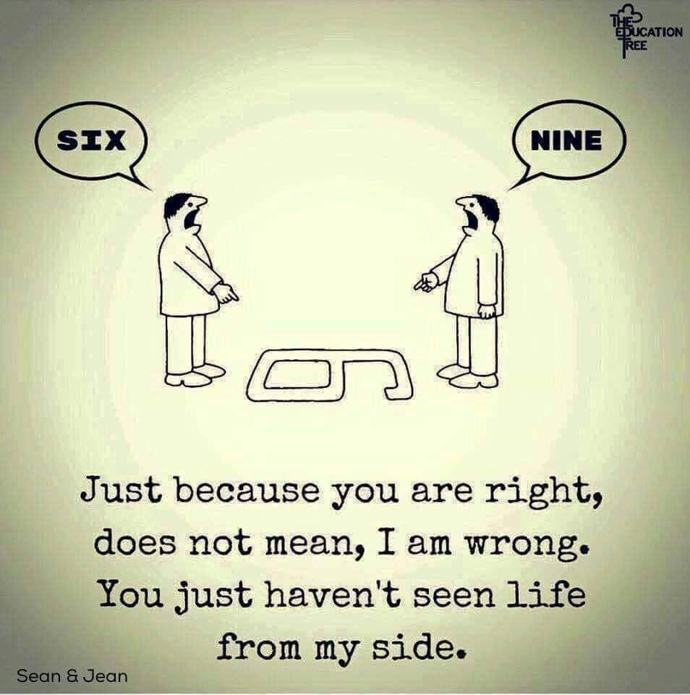

6) TARDIS: Time And Relative Dimension In Space

As conflict escalates, our spacial orientation changes and our sense of time changes. (Give LSD example of 60 seconds—heightened speed and adrenalin make it harder to track time).

Get closer.

For most, when you are fighting your words speed up.

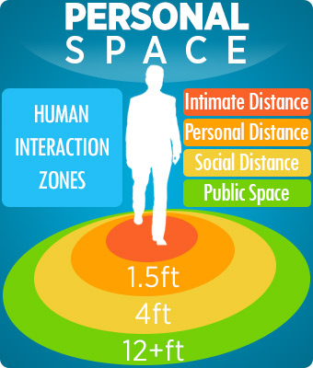

### 10:15-10:25 Break

### 10:25-11 PON 4 Key Strategies

1. Separate the people from the problem
2. Focus on interests, not positions
3. Generate options for mutual gain
4. Use objective criteria

<https://youtu.be/w7cgAD7XSGM> Reframing purpose video, first 5 minutes.

### 11-12 Historical, Current, and Future Interests

We will look at what interests a mediator typically looked for in a mediation, what is more common now, and based on these trends what will people’s interests be in the future.

<https://youtu.be/PoHuEP79wUQ> take notes and identify key interests: what is timeless? What is dated?

### 12-12:30 Lunch (Participants provide their own lunch)

### 12:30-1:30 Common Negotiation Tools

## 3. Negotiation Tools

Ice-Breaker: My role as a mediator is to ___________ (1 word)

Personal Conflict: How did you negotiate? See if you can identify your negotiation tool in the list below. Negotiation Tools are most important when you reach an Impasse: when parties appear to be stuck, loss of momentum, seemingly irreconcilable (kids and laundry basket).

**When things get stuck:**

Participants read definition and try to come up with an example.

1. Ask why: (2 sisters and orange—we assume we know why something is important but we usually don’t)
2. **Backatcha:** Ask a Dudley Impasse breaker/a phrase that throws the process back at them
3. Take a break: Conflict is emotionally draining. Taking a walk, making tea—physically doing something diminishes stress and encourages creativity.
4. BATNA: Best Alternative To Negotiated Agreement. If you walk out of here today without an agreement, what is your best scenario for this conflict ending?
5. WATNA: Worst Alternative to Negotiated Agreement: If you walk out of here today without an agreement, what is your worst scenario for this conflict ending? Court ruling against you and your credit score plummets?
6. Caucus: <http://www.youtube.com/watch?v=zXUkpSe1GHY> Video about caucus and showing what it’s like with three parties. Caucus: A private conversation with only one party at a time. Review what information you have permission to bring back to the other party.
7. Brainstorming: Carefully state that no judgment is allowed. Write down any and every idea. When momentum slows, suggest your own crazy ideas.
8. Non-verbal tools: Turn chairs. Cross arms. Look out the window. Hand them paper and pen for taking notes.
9. Strategic, decision-making process (per Robinson and Lowry): Seeing negotiation as a series of strategic compromises. What are you willing to let go of in order to gain X?
10. Silence: ___________.
11. Competitive v. Collaborate. Demonstrate to people that they are being competitive and they need to make an attempt at being collaborative. This helps people to stop focusing on each other and instead on the problem. Let’s move from Me versus You to Us. Competitive example erin brokovitch <http://www.youtube.com/watch?v=5Jdk3riKKwo>
12. **Expand the Pie**: Create Options. Conflict myopia. Student stand in corner.

### 1:30-1:45 Break and review Negotiation Keys

### 1:45 – 2:15 Jedi Negotiation Tools

<https://docs.google.com/presentation/d/1THW0RwSupBcFFzYfcmSyt-gVKLheUfq1a8TM7_on0cY/edit>

How to exit a conflict when things get really stuck:

Thermometer

Taking Out the Garbage

ELF

Straight, No Chaser

### 2:15-3:15 Large Group Role-Play 11

**Large Group Role-Play 11 Stop Sign**

Mediator Welcome and forms

Mediator Statement and Ground Rules

Parties’ Opening Statement

Listen

Reframe

Take Brief Notes During Opening (I)

Draft Agenda

Negotiate Items on Agenda

Take Notes During Negotiation: Note-sheet: Interest, Offer, Question, Agreement, Clipboard (I, O, ?, A, C)

Caucus

Identify Escalations  
Identify Points of Agreement

Try using 2 exits

### 3:15-3:30 Break

### 3:30-4 Debrief Role-Play

Review Power imbalance

Escalation signals

Escalation momentum

Exits

Agenda

What is needed in an agreement?

### 4-4:30 Prisoners Dilemma

Where aggression comes from:

<http://www.youtube.com/watch?v=_ZpDnXYIFjo>

Why do people feel that they need to escalate?

Don’t want to be seen as weak

Afraid that the other side won’t be kind

|  |  |  |
| --- | --- | --- |
|  | **Prisoner B collaborates** | **Prisoner B protects him/herself** |
| **Prisoner A collaborates** | Each serves 1 month | Prisoner A: 1 year  Prisoner B: goes free |
| **Prisoner A protects him/herself** | Prisoner A: goes free  Prisoner B: 1 year | Each serves 3 months |

Escalation:

1. Thing escalate quickly when we are only focused on what we want
2. If we play nice and the other one doesn’t, the next move will probably be an escalation.
3. Pay attention to precedence
4. Rising tides raise all ships; sinking tides sink all ships.

### 4:30-5 Review Negotiation Phase

Negotiation Tools Developed

Agenda

Note-Taking: I, O, ?, A, C

Negotiation Tools

### Keys for N: Negotiation

Beside the money, what else would you like?”

“What would you like to see happen?”

“What are your expectations?”

“Help us understand how this has impacted your life.”

“What would be the ideal outcome? What would work best for you?”

“What interests would be served if you got some or all of your aspirations? Name some more.”

“How do you want things to be different? Better? Improved?”

“What are the important things you want from this meeting?”

“When you go home tonight, what would you like to have accomplished?”

“What is the problem that your position solves for you?”

“What are your goals in negotiating for that position?”

“How does that position help you?”

“What are the consequences of not having ____?”

“What do you want to get out of this? Don’t give me a number yet; just tell what other needs go with this situation.”

“In what ways will their position hinder what you’re trying to accomplish?”

“What will relief or resolution allow you to do?”

“Beside the money, what other interests or concerns do you have?”

“What are the values associated with __________ (object) or (action)?”

“Beside the hard facts, what assumptions, beliefs and interpretations are at work to get from the facts to the conclusions? How do any of these hinder a solution?”

“What background feeling goes with what you’re saying?”

“Why do you feel ________ (or) that way? “

“What leads you to say that?”

“What’s behind that statement?”

“Now I’d like to learn why you state a position that way.”

“What is meant by that?”

“Talk about your reasoning on __________”

“Just so I have a more complete picture, please tell me ____”

“Would you like to add anything further? Anything else?”

“What else do you want to mention?”

“Is there anything you’d like to add?”

“Have I missed anything?”

“Would you say more about that?”

“Would you mind expanding on that a bit?”

“Why is _____ important to you?”

“Is that an okay spot to stop for now?”

### Notes for Negotiation

# Session 4: Agreement

### 8-8:30 Review

Sonar discovers hidden treasures.

Review Statement : (Create happy, host)

Review Opening: (Create knowledge, shovel)

Review Negotiation: (Create value, pick)

### 8:30 Maxim: My Contribution

### 8:30-9 Purpose of Agreement

**Agreement (Create precision, ruler) Be 6 months ahead.**

Example of contractor in house-building

**Goal = Precision**

### 9-9:45 Setting the Stage for Agreement

## 1. Identifying Exits

**Developing Agreement Items**

After you have identified items on your negotiation agenda that appear to be agreements, begin writing them down on an agreement sheet.

**Conflict Path Review: Personal Conflict Exits**

Show how this is one step toward parties’ goals

Parties might be satisfied at this point, happy, relieved, nervous. They are beginning to exit the conflict. They may want an apology, a handshake, or a treatise explaining their agreement.

Ask parties for help framing clauses in agreement

Ask Confirm agreements, but don’t push or expect too much

Personal Conflict 1 on 1, opening, negotiation, practice tactic, draft agreement

### 9:45-10 Break and review Agreement Keys

### 10-10:45 Develop Agreement

<http://www.mediate.com/articles/urytedvideo.cfm> Bill Ury developing agreement

(might also be referred to as Memorandum of Settlement, Memorandum of Understanding, or Mediated Settlement Agreement)

**Standard Settlement Agreement Provisions:**

* Mutual releases of liability
* Names, roles, dates, time
* Dismissal of lawsuit(s)
* Timelines for payments, interest, security, liens
* Form of payment
* Confidentiality clauses
* Cooperation in preparing documents necessary to effectuate agreement
* Payment of attorney fees
* Resolution of all claims and defenses
* Dispute resolution clauses, i.e., mediation, arbitration, allocation of costs
* Agreement entered freely, voluntarily, without duress or coercion and with the advice of counsel
* Admissible as evidence in any action or legal proceeding to enforce its terms

Enforceability:

Is everyone necessary present?

Were the terms clearly explained with everyone in the room?

Was it outlined in the agreement?

If someone is not abiding, it can return to mediation, have mediator act as arbitrator, or court.

If court, parties must file a motion of enforcement.

## 2. Develop Agreement

**Large Group Activity: Discuss Stop-sign agreement items**

Personal Activity: Write agreement for example

### 10:45-11 Difficulties of Agreement

Impasse and psychological resistance to agreement  
 Negative intimacy

Death rumblings

Admitting you made a mistake

### 11-11:45 Lunch

### 11:45-12:45 Agreement Specifics

**Agreement Standards**

Use inclusive language whenever possible

Over-specify

Determine if contingencies are needed if agreement is not honored

Include both practical and emotional agreements

Track small agreements as they are made

Specify Service

Specify Date

Who needs to be involved/notified

Contingency Plan

Future Plan

Working Plan

Filing with Prejudice or without Prejudice

What elements would need to be included in:

Workplace mediation agreement

Relationship agreement

Landlord tenant

### 12:45-1 Review SONAR and steps (refine statement and note-taking sheet)

### Vacation Ice-Breaker

**Agreement**

Ice-Breaker: National Lampoon vacation

Quickly describe your worst vacation. Partners listen closely. Now partners? Reframe.

### 1-1:45 Small Group JJ Role-Play 12

**JJ Complete Role-Play 12, w/ Agreement**

JJ Small-group role-play—complete with groups of 4

### 1:45-2:30 Debrief Role-Play, Review Agreements

Examine agreements. What elements are strong and what needs to be tightened?

### 2:30-2:45 Break

### 2:45-3:15 Resistance to Agreement

**Resistance to Agreement**

Group Brainstorm

Impasse

What to do when it falls apart (amygdala v. pre-frontal cortex—show what happens when brain goes off-line)

What happens when:

Agreement fails at last minute (take a break, review, discuss BATNA and WATNA)

Agreement changes: say it’s fine, ask for them to reword it

Agreement enforceability: submit to court, notarize, both keep copy, mail a certified letter, have agreed upon check-ins

Agreement Options: Expanding the Pie

**Share resistance from personal conflict**

### 3:15-4 Mediator’s Role

## 3. Define Role

Neutral: Omnipartial

Remove Bias

Flexible

Navigate Impasse

Not here to be convinced! Not here to give legal advice!

What word would you use to describe mediation? Keep going around room until someone repeats a word. Write down your three favorite and add those to your Mediator Statement.

Note that your role shifts from beginning to end—but there will be some roles you enjoy more.

### 4-4:30 Importance of Precise Communication

**PBJ** example: designed to show you the importance of a clear and detailed agreement.

Review possible entrances and escalations. Having more information in the beginning improves the end result.

### 4:30-5 Review Agreement Phase

Agreement Phase Tools Developed

Identifying Exits

Develop Agreement

Define Roles

To prepare for tomorrow:

16personalities.com, Riskin’s Grid, and 5lovelanguages.com

Which of these 6 are you most looking forward to doing tonight/ when you are exhausted, what brings you energy/recharges you

1. Realistic: physical engagement, get active, be in the middle, the doers, architecture, construction, possibly physical therapists because they still like the how of things work, sports. Arts, dance.
2. Investigative: research, learning information, collecting data, digging out what is not important, break things apart, analyze them, understanding why thing work is like psychology, culture like fundraising, understanding the aspects of a case, researcher like understanding terrorism, intelligence. It’s all about digging in, research, analysis. Digger.
3. Artistic: creativity, self-expression, new ways of presenting things. New. Have to be very creative in looking at new constructs, new policies, business owner, entrepreneur.
4. Social: interest in working with people to help them. You want to make a difference in their life. Help them leave their life in a better condition than they were. All the services are in here: career services, social services, teacher, etc.
5. Enterprising: interest in working with people, to persuade them, shift their paradigm, persuade about products, marketing, fundraising, development, change their ideas.
6. Conventional: interest in organization, wanting to bring structure, planning, order to things that are organized. You might like to organize people and you are in management, space, mechanics, strategy, consultant, help people strategize.

### Keys to A: Agreement

“It’s clear you both share the common goal of reaching a mutually acceptable resolution.”

“The key is to expose your needs and interests to each other and listen with an open mind. Focus on ways you can help the other person get their needs met.”

“This is not a contest to be won; it’s a joint problem-solving quest for a reasonable compromise solution.”

“At this point it’s time for both sides to begin working together to explore options toward a solution.”

“Okay, now I want you to use your considerable problem-solving abilities.”

“Now we’re going to think about some optional ways to resolve the dispute. As many ideas as possible.”

“I want to hear suggestions and tentative ideas about how you might overcome your differences and come together on some aspects of an agreement.”

“What would be your suggestions?”

“What ideas do you have about how this might be solved?”

“How do you want things to be improved?”

“What would work well for you?”

“Do you see yourself in a different position in the future?”

“New options and opportunities can be discovered when you view the problem from as many perspectives as you can.”

“Think about what it would take to get this resolved … for you and for them. What are some of the ways that come to your mind?”

“Think outside the box. As Einstein famously said: “We can’t solve problems using the same thinking that created them.” Use imagination, intuition and creativity.”

“From what you’ve learned about their interests, how would you shape the elements of a deal that would be very beneficial to them in their eyes … while not too bad for you?”

“If there are benefits to one party that cost less to the other party … you’re enlarging the pie to be divided.”

“What do you want? What would you like to see happen today? “

“What ideas do you have on how this dispute could resolve itself? [Then, to other side] Without responding to what they just said, give your own fresh answer to the same question.”

“This is the open discussion period where you ask each other questions, respond to what’s being said and fill in the information gaps.”

“It helps a lot if you show a little appreciation for anything good they say.”

“Everyone is doing the best they can to get their needs met. Each has their own set of needs and their own sense of what’s fair and right.”

“If you look out for their interests very likely they will look out for yours. “

“The art of compromise is the willingness to give up something in order to get something else in return. We’re looking for trades.”

“Instead of an outcome being imposed on you, you can help determine it and it may not come from law; it may come from goodwill.”

“You can “agree-to-disagree” on past facts and think about where they want to go from here.”

“I hear you taking responsibility for what you feel were some mistakes. That’s often given credit by the other party. In what form would you like credit?”

“What could you have done differently to help avoid what happened?”

“Let’s move to constructive problem solving. What more information from ___ would you like to have in hand as you begin creating steps toward a solution?”

“Rather than rehashing the past, let’s focus on the future where there haven’t yet been any problems.”

### Impasse

“Sometimes virtue is its own reward. No one and no bad treatment can take it way.”

“There’s always a natural tendency to focus so much on their character that your tangible interests don’t get enough attention.

**Impasse Approach: What If’s**

“How would you react if the other party made this suggestion? ___ How would you modify this suggestion?”

“What if you could design a payment plan. How would it look?”

“What if you include non-monetary compensation, such as ______? Any ideas?”

“How would you think about this other option? _____. I’m not trying to convince you to take it, only to make sure you know about it and can consider the advantages and disadvantages. The choice is yours.”

**Impasse Approach: Role Reversal**

“Stand in the other person's shoes for a bit and look at the issue through their eyes. How would you resolve it if you were over there?”

“If you were them, why do you think your proposal wouldn't be workable?”

“If you were them, why would you accept your proposal?”

“How would you tweak their proposal to make it better for you but still not too bad for them?”

“What are some of the criteria that would make it good for you? Bad for you? “”

“How about you being the mediator for a bit. Tell me what you heard them say.”

“Be the jury for a minute. Try imagining it from a totally impartial, objective perspective.”

**Impasse Approach: Future and Future Relationships**

“I’ll bet you can each make a pretty good case for why it’s not your fault. But I don’t think it’s going to help you much to be arguing about it. You need to shift the question from “whose fault is this?” to “How might we resolve this problem ourselves?”

### Notes for Agreement

# Session 5: Resolution

Share follow-up info

### 8-8:15 Review and Ice-Breaker

SONAR:

SONAR has a purpose. Each of these steps are leading us to something. We don’t know in the beginning where it is leading us or how we will get there, but we know it will be better than where we are at right now.

This resolution, how we walk away from it all, reviews what has been discussed, sets the tone of their future relationship, and often brings closure.

It doesn’t end with agreement. Our job is not just to bring about agreement—but to help.

Statement (happy)

Opening (digging)

Negotiation (value)

Agreement (precision)

Resolution (The art of ending well: How does this look tomorrow?)

**Ice-Breaker**: My favorite tool in my toolbox (something we’ve discussed or something new)

Tell JJ Resolution Story.

### 8:15 Maxim: Conflict is an Opportunity to Strengthen Relationships

### 8:15-8:45 Resolution

## 1. Bring Resolution

**Why do we mediate?**

Spiritually: People desire stability, peace, and effective communication

Emotionally: Draining to live in conflict

Economically: Mediation saves money and time when resolving a dispute

Close the mediation for all involved

Review the Agreement

Review items not discussed/clip-boarded (IF HELPFUL!)

Envision how things will change going forward

Remind them of their goals

Acknowledge the Difficulties

Congratulate them on their bravery, collaboration, etc.

Review Forms and Evals

**Goal: Create art (vase)**

**Creating art**—the art form of knowing how to communicate, turning a pile of gunk into something of value

1: A strong hand causes cracks, needs patch-up work at end (gorilla vase)

2: With a vision, know what steps to take, time to finish, did it’s job (daffodil vase)

3: With experience and vision, it not only does it’s job—it’s beautiful (sake vase)

4: An artist shows heart and story (shows value of their culture, not ours) (Chief Justice at Hong Kong High Court serving tea out of his family’s tea set)

When requesting that parties give their opening statements, there are a few ways you can go depending on how much time you have. I am going to teach you the basic and most common process. But you also have to realize that you are the mediator. If straying from this process or adding to it will help your clients (and it’s legal!), then go for it.

How do we close? What do we leave parties with?

### 8:45-9 Break (review Dudley Resolution Keys)

## 2. Ethics

### 9 – 9:45 Ethical Considerations and Review Questions

Cultural awareness in mediation

Interpersonal communication skills

Awareness of Bias

Asking good questions (open-ended, simple)

Certification

Ethical considerations (conflict of interest,

Clipboarding

Empathy v neutrality

(role-plays:

1. Drug trial: Marcia works at a drug testing company where they are seeking additional capital from Robert, the investor. You negotiate the terms of a good agreement for them. As Robert is signing the agreement, Marcia mentions, “phew, thank goodness we got that investment before they realized this drug doesn’t work!”
2. AA: You think you recognize one of the parties. You ask, but they say they don’t recognize you. You continue mediating. As you go farther in the mediation, the wife mentions that she is concerned that husband should not have custody of the kids due to a drinking problem. Then you remember—you recognize the husband from AA. You know he used to talk about drinking, but can’t remember if he has said lately that he is still drinking.
3. Family gives cherished home to people posing as a couple. When you see them leave, they pull hands apart and their bumper sticker says “We flip houses for you!”
4. Negotiating land deal when one side has told you that they know that there is oil on it
5. CIA: Security software

Getting to Yes says that any method of negotiation may be fairly judged by four criteria: It should produce a **wise** agreement, it should be based on , it should be **efficient**, and it should **improve or at least not damage the relationship** between the parties. (GTY, 4) Transformative Mediation says that a resolution should result in people not just being better off but better. In a world in which people remain the same, solved problems are quickly replaced by new ones (PM, 29).

Caucus: What are important considerations in caucus to ensure that you are being ethical?

### 9:45-10 Break

### 10-12 Ethics

Guest Lecturer Michael Lang

### 12-12:30 Lunch (Certificates provided by instructor on final day)

### 12:30-1:30 Finalize Forms

Review and edit Mediator Statement, Agreement to Mediate and Confidentiality Forms, Note-taking forms, Mediation Agreement, and Evaluation.

### 1:30 -2 Mediation Styles

## 3. Mediation Styles

Identify your style: Holland Code, Facilitative/Evaluative/Transformational/Transactional.

Be familiar with other tests (16personalities.com, Riskin’s Grid, and 5lovelanguages.com). Great tools and impasse breakers.

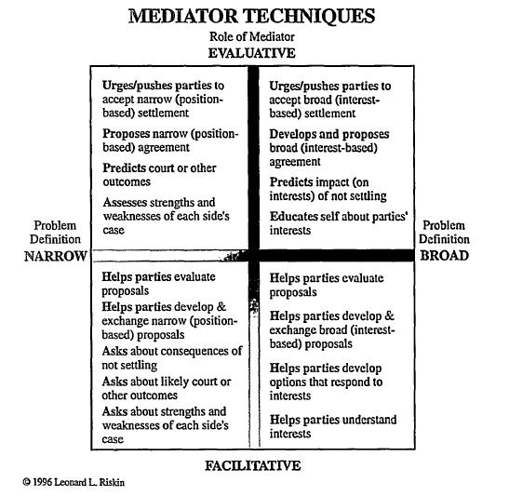

**1: Facilitative Mediator**: **Guide**. Gently guides people through process, advising procedurally. What type of mediations would need a facilitative mediator?

**2: Transformative Mediator: Therapist.** Sees the relationship as more important than the issue. Mostly discusses forgiveness, future communication processes, and relationship repair. What type of mediations would need a transformative mediator?

**3. Evaluative Mediator: Judge.** Bordering on arbitration. Mediator gives opinion and evaluates the case. What type of mediations would need an evaluative mediator?

**Holland Codes**

So we have these 6 approaches to resolving conflict. I want you to grab the paper in front of you and a pen, and go to the place in the room that you most identify with.

Now as I go along, if you feel that you are more closely identified with a different style, I want you to move there. As we go through I want you to write down 3 styles that kind of fit you. When we’re done, you’re going to rank them 1,2,3 by what describes you most.

1. Realistic: physical engagement, get active, be in the middle, the doers, architecture, construction, possibly physical therapists because they still like the how of things work, sports. Arts, dance.
2. Investigative: research, learning information, collecting data, digging out what is not important, break things apart, analyze them, understanding why thing work is like psychology, culture like fundraising, understanding the aspects of a case, researcher like understanding terrorism, intelligence. It’s all about digging in, research, analysis. Digger.
3. Artistic: creativity, self-expression, new ways of presenting things. New. Have to be very creative in looking at new constructs, new policies, business owner, entrepreneur.
4. Social: interest in working with people to help them. You want to make a difference in their life. Help them leave their life in a better condition than they were. All the services are in here: career services, social services, teacher, etc.
5. Enterprising: interest in working with people, to persuade them, shift their paradigm, persuade about products, marketing, fundraising, development, change their ideas.
6. Conventional: interest in organization, wanting to bring structure, planning, order to things that are organized. You might like to organize people and you are in management, space, mechanics, strategy, consultant, help people strategize.

OK, now rank them 1, 2, 3. Now move back to your #1.

Make cards that say

1. Purpose = how you should spend your time. Doing this you will be most satisfied and most effective.
2. Strategy = you’re good at this, but not passionate about this. For a lot of people this becomes your day job, and your purpose is how you spend you time on evenings and weekends
3. Tool = you know how to do, but it’s not really how you enjoy spending your time. You’ll do it if you have to. Like doing taxes. Blech.

OK—now we are going to put this in terms of conflict resolution and how does this relate to you.

**Realistic** – Doer, practical, physical, hands-on, tool-oriented:

A) Consultant, Arbitrator, Judge, Judicial Expert

B) Determined, Frank

C) Process conflicts, factual

**Investigative** – Thinker, analytical, intellectual, scientific, explorative:

A) Ombuds, Investigator, Union Rep, systems analyst, cross-cultural

B) Intellectual, Scholarly

C) Systemic, External

**Artistic** – Creator, creative, original, independent, chaotic:

A) Friend of the Business, Mediator, Create handbooks, conduct seminars, Inspirational Speaker

B) Original, Independent, Expressive

C) Interpersonal and Opinion/Subject

**Social** – Helper, cooperative, supporting, helping, healing/nurturing:

A) Therapist, Coach, Employee Relations, Social Worker, Teaching sessions, Counselor

B) Helpful, Informative, Intuitive, Excellent at Interacting with people in multiple situations

C) Relational

**Enterprising** – Persuader, competitive environments, leadership, persuading:

A) Systems Design, Start a business, Trainer, Public Policy, Lobbyist, Speech, Lawyer

B) Adventurous, Sociable, Persuasive, Energetic, Ambitious

C) Bullying/Power

**Conventional** - detail-oriented, organizing, clerical:

A) Grievances, HR, Expert, Conflict Examiner, Firm Manager

B) Conscientious, Structured, Detail-Oriented

C) Task/Process disputes

Based on your Holland strengths, what style do you think comes most naturally to you? What will you be the most effective at?

### 2-2:15 Break

### 2:15-2:45 Next Steps

Next steps:

Advice for volunteering and gaining experience

Careers in Mediation

Mediate.com Newsletter

Evaluation/Next Steps for me.

### 2:45-3 Resolution Questions

Resolution: Considering the Future

What do we do 6 months from now? A year from now?

How do we agree to treat each other?

Does this affect our legal actions against each other?

Do we need a check-in?

Do we need to verify that the agreement is enforced?

Who contacts who?

What did we accomplish today?

### 3-3:45 Large Group Role-Play HOA v. Foster Family

Room Set-up

Mediation Styles

Note-taking

What is in your agreement?

Resolution Tools

### 3:45-4:30 Mediation Issues/ Questions

**Review FAQs**

Ethical Considerations

Confidentiality (https://www.mediate.com/articles/hobbsk1.cfm)

Legal Advice

What to do when you are personally offended as a mediator?

What to do when you are scared?

Do you have to be a substantive expert?

How much of this can be applied personally?

What do I do when I’m stuck?

How do I draft an agreement?

What happens if the parties start yelling?

What if we don’t settle in time?

What if there is a history of domestic violence?

Are mediators mandatory reporters?

What can I say about the mediation to a reporter (Sandy Hook example) or to my best friend?

Additional questions from notes page

Pictures

### 4:30-5 Resolution Tools Developed

Resolution

Mediation Styles

Next Steps

### Keys to R: Resolution

“Give yourself a reality check. What’s your certainty level? 90%? 80%? 50%?””

“How strong is the legal merit and provable damages in this case?”

“How weak is the legal merit in defense and the possibility of facing a high verdict?”

“What do you want? What are you doing to get it? Is that working? If not, what can you do differently to make it happen?”

“Consider what you have control over and what you don’t:

Behavior or decision of judges -- No

Decision of juries -- No

Movements by the other side in negotiation -- No

The way the other side evaluates the case -- No

The way the other side opens with lo-ball or high-ball offers --No

The pace the other side moves with counter-offers -- No”

“So, what’s left?

Your own case evaluation -- Yes

Your own negotiating range -- Yes

Your own movement at any time -- Yes

Your own stopping point in negotiations -- Yes

Your pride in your actions here today -- Yes”

“Take a long hard look at the reality of your situation.”

“Test your perception: How much is it like dreamlike desires vs. hard reality?”

“At this point you might step back and ask yourself: “To what extent am I approaching this as an exercise in make-believe; in a fantasy of ‘let’s pretend’ I’m going to get everything I want.”

“Let’s try a reality check from this standpoint. Have you considered ____?”

“Have you had experience with the same kind of case, same facts, same judge?”

“Ask yourself if your experience with situations just like this is sufficient to predict what the judge will do.”

“What people often don’t take into account is the fact that spending more time thinking about all the things in one’s own case results in overconfidence.

Opposing facts, evidence, arguments and legalities don’t get thought about as much, distorting one’s judgment.”

“You know you lack (e.g. the necessary written documentation to support your case) don’t you? How would a judge or jury be convinced that you ____? Plus, as you may be aware, ___ has ____ (e.g. two witnesses, both prominent in their field prepared to testify on their behalf.)”

“Now I'd like each of you to be a Devil's Advocate and argue against your own position.”

“May I be a Devil’s advocate for a bit? Will you me permission to be blunt and direct?”

“May I give you an outsider’s view of it:?”

“How well do you meet the four-part legal standard of reasonableness? 1. Duty to care as a reasonable person would. 2. Breach of duty. 3. Causation with proof. 4. Damages with certainty of value.”

“We could argue or dispute the legal aspects all day and night. Or, we could try to get a negotiated solution to resolve them in a manner that helps satisfy the aspirations of both parties.”

What do we do 6 months from now? A year from now?

How do we agree to treat each other?

Does this affect our legal actions against each other?

Do we need a check-in?

Do we need to verify that the agreement is enforced?

Who contacts who?

What did we accomplish today?

### Notes from Resolution

**Justin and Julie Example of a Mediated Agreement**

We, Justin and Julie, agree that Justin is willing to reduce the amount from $,1500 (one thousand five hundred) to $1,000 (one thousand) and is willing to accept this amount in the payment schedule described below conditioned upon Julie letting Justin keep the dog until October 18, 2013.

Justin pays the dog bills (including up-to-date vet fees, food, grooming, deworming).

On October 18, 2013 we, Justin and Julie, agree that Justin brings the dog to Julie’s home. Julie will pay all dog fees. Justin may have the dog for 6 (six) agreed-upon days per calendar year, every year, for hunting.

We, Justin and Julie, agree that Julie will pay $500 (five hundred dollars) today (April 18, 2013) by personal check, dated today (April 18, 2013).

By May 1, 2013 before close of business, Justin will dismiss the suit in court by filing a motion and order of dismissal with prejudice consistent with this agreement. Also by May 1, 2013, Justin will send Julie a receipt of the first payment. He will also provide proof of dismissal (a copy of the original) to Julie. Justin will retain the original.

We, Justin and Julie, agree that Julie will pay $500 (five hundred) by personal check by mail, post-marked May 15, 2013.

Justin calls Julie May 15, 2013 at 2 pm on this xxx-xxx-xxxx.

We, Justin and Julie, agree that Julie will sign a Confession of Judgment for the full amount $1,000 (one thousand) + court costs.

# Dissertation Facts

Entrances to Conflict

|  |  |
| --- | --- |
| **Theme** | **Entrance** |
| Bad Communication | 60 (23%) |
| Mean Communication | 49 (19%) |
| Unclear Job Description | 23 (9%) |
| Group/Personality Conflicts | 17 (7%) |
| Entitlement | 14 (5%) |
| Unclear Protocols/ Feedback | 14 (5%) |
| Business Decisions | 13 (5%) |
| Unfair Treatment | 11 (4%) |
| External Customer/Contractor | 11 (4%) |
| Physical Office | 10 (4%) |
| Unappreciated | 8 (3%) |
| Poor Work Ethic | 7 (3%) |
| Unrealistic Deadlines | 6 (2%) |
| Bad Attitude | 6 (2%) |
| Family/Home Issues | 4 (2%) |
| Scheduling | 3 (1%) |
| Discipline | 3 (1%) |
| Cultural Differences | 1 (0%) |
| Not Enough Pay | 1 (0%) |
| Personal Use of Resources/Theft | 0 (0%) |
| **Total Identified Conflict Entrances** | **261** |
|  |  |
|  |  |

Conflict Exits

|  |  |
| --- | --- |
| **Conflict Exits** | **Frequency** |
| Direct and Honest Communication | 47 (53%) |
| Mediation | 19 (21%) |
| Management Intervention | 14 (16%) |
| Not Resolved | 3 (3%) |
| Office Décor | 2 (2%) |
| Police | 2 (2%) |
| Fired | 1 (1%) |
| Training | 1 (1%) |
| **Total Identified Exits** | **89** |

Escalations of Conflict

|  |  |
| --- | --- |
| **Theme** | **Source** |
| Bad Communication | 53 (13%) |
| Unclear Job Description | 43 (10%) |
| Poor Work Ethic | 39 (9%) |
| Mean Communication | 35 (8%) |
| Unfair Treatment | 33 (8%) |
| Entitlement | 30 (7%) |
| Unclear Protocols/ Feedback | 26 (6%) |
| Cultural Differences | 20 (5%) |
| Physical Office | 19 (5%) |
| Unappreciated | 18 (4%) |
| Business Decisions | 17 (4%) |
| External Customer/Contractor | 14 (3%) |
| Unrealistic Deadlines | 13 (3%) |
| Group/Personality Conflicts | 11 (3%) |
| Scheduling | 11 (3%) |
| Bad Attitude | 8 (2%) |
| Discipline | 8 (2%) |
| Not Enough Pay | 8 (2%) |
| Family/Home Issues | 6 (1%) |
| Personal Use of Resources/Theft | 2 (0%) |
| **Total Escalations of Conflict** | **414** |

Comparison of Entrances to Escalations

Who Started the Conflict

Uncondensed Processes

|  |  |  |
| --- | --- | --- |
| **Conflict Resolution Processes** | **Raw Total** | **Percentage of all Processes** |
| Compassion and Understanding | 46 | 9.85% |
| Conversation/ Collaboration | 45 | 9.63% |
| Pre-training | 38 | 8.10% |
| Mediating | 36 | 7.88% |
| Post-training | 35 | 7.66% |
| Honesty | 30 | 6.35% |
| Meeting with all involved | 28 | 6.13% |
| HR/Management forcing people to be nice | 26 | 5.69% |
| Stronger Leadership | 22 | 4.81% |
| Address early | 21 | 4.60% |
| Let it go | 21 | 4.60% |
| Firing | 16 | 3.50% |
| Peaceful décor | 14 | 3.06% |
| System redesign | 14 | 3.06% |
| Police | 13 | 2.84% |
| Agree to Disagree | 12 | 2.63% |
| Neutral/ Facilitation | 12 | 2.63% |
| Reorganizing | 12 | 2.63% |
| Focusing on Issue instead of Person | 7 | 1.53% |
| Paid time-off/break/space | 5 | 1.09% |
| Apology | 4 | 0.88% |
| **Total Identified Conflict Resolution Processes** | 457 | 100.0% |

Consequences of Conflict

|  |  |
| --- | --- |
| Resolution Method | Frequency |
| Remained Quietly Under the Surface | 1431 (40%) |
| Resolved Amicably | 1006 (28%) |
| Faded Away | 740 (21%) |
| Very Disruptive or Violent | 394 (11%) |
| **Total Resolution** | **3571** |
|  |  |

# Resources

### SONAR

S: Statement to the parties about mediation. My personal statement:

O: Openings by the parties. What phrases and reframes will I use?

N: Negotiation. What statements will I use to advance the negotiation?

A: Agreement. How will I organize the agreement? What needs to be included? What forms do I need?

R: Resolution. What do I need to include in my resolution? What are the key elements that I want parties to walk away with?

### My Personal Conflict page

*Use this page to jot down information about your personal conflict. We will use this conflict throughout the week as an example to help us understand conflict theories. It does not need to be complex, just something simple.*

Begin by jotting a few sentences about your conflict:



### Toolbox

Mediator Statement

Caucus

Silence

Ground Rules

Reframing

Columbo

Gentle

Aggressive

Clipboarding

BATNA

Brainstorming

Agenda

Apology

### Example Mediation Notes

## Parties’ Opening Statement Notes

|  |  |  |  |  |
| --- | --- | --- | --- | --- |
| **Alex** | | **Notes** | **Susan** | |
| I | Thinks she doesn’t work hard enough |  | ? | Hasn’t received any management support |
| ? | Wishes she would do more work |  | I | Applied for trainings, but always told she was needed in her current position |
|  | Wishes she could work faster |  | C | Doesn’t like her secretary |
|  | Wants to have her move up be a boss | A |  | She wants to move up to be a boss |
| ? | She was hired to move into management |  |  | Admits she got frustrated and “gave up” |
| O | Willing to give her paid time-off for a 2-day mngmt seminar |  | O | Would like to try to be a Project Manager to show them she’s ready to recommit |
|  |  |  |  |  |
|  |  |  |  |  |
|  |  |  |  |  |

I: Interest or Issue

?: Review this

O: Offer

A: Potential Agreement

C: Clipboard

### Glossary

**ADR**: Alternative Dispute Resolution, sometimes referred to as Appropriate Dispute Resolution

**BATNA**: Best Alternative to a Negotiated Agreement

**Caucus**: meeting with a party separately

**Ground Rules**: guidelines for communicating and behavior to support an effective conversation

**Impasse**: When a mediation feels stuck/an obstacle feels insurmountable

**Interest**: A party’s underlying concern

**Mediator**: an objective third party that guides a discussion between multiple parties

**Position**: What a party says is important to them and they feel they need to defend, their stance on an issue

**Power Imbalance**: When there is a perceived imbalance of power, where one party appears to have less power than someone else in the mediation

**Toolbox**: a mediator’s set of communication and process skills, used when and where a mediator feels appropriate

Avoid: Refuse to Engage

Compete: Try to win

Compromise: I get a little, you get a little

Accommodate: Engage, but then back down

Collaborate: Look for win/win

### Acknowledgements

Institutions:

Straus Institute, Pepperdine University School of Law

Fulcrum

Supreme Court of HI

NW Mediation

Yakima DRC

Campus-ADR.org (http://www.campus-adr.org/CR_Services_Cntr/MIT_all.pdf)

Mediate.com

University of Oregon Conflict Resolution Center

Leaders:

Peter Robinson

Nina Meierding

Ken Cloke

Jim Melamed

Randy Lowry

John Wade

Michelle LeBaron

Dudley Braun

Don Saposnek

# Role-Play: Justin’s story

I have loaned her so much money! I can’t believe that she hasn’t paid me back!

We dated for a couple years. We broke up over a year ago.

Right before we broke up, I loaned her $1,500 for her transmission. She fixed it with my money. Then we got in a big fight and we haven’t spoken since.

**Justin Negotiation**

If she would at least discuss this, or own up to it, or apologize I would feel better. She won’t return my calls. I really didn’t want to sue, but I didn’t know what else to do.

She knows how tight money was for me when we were dating. I was in school full-time, and she was working part-time. If I had money I wouldn’t have asked for help for the transmission, but we both agreed that it was important that I finish my degree with good grades before I looked at a job.

I’m actually kind of embarrassed that I’m even in Small Claims Court.

I miss our dog.

# Role-Play: Julie’s Story

The fact that he is complaining about a transmission now is ridiculous. If he goes through with this suit, I am going to countersue. This is embarrassing. It is a waste of my time. He might still be mad at me—but that doesn’t mean you sue someone!

This all just goes to show how immature he is.

**Julie Negotiation:**

I have given him so much money!

The whole time we were dating I paid for everything. His tires, most of our dinners, and I always bought him new clothes.

I don’t know why he said he kept calling me—I don’t think he ever did.

I miss his parents. We became pretty close.

When we broke up, I took the dog since I was moving closer to a dog park. It has been a great, full-time companion.

# Large Group Role Play: Stop-sign

PTA vs. School Superintendent vs. City Council

At Warner Oaks Elementary, there have been a few complaints about children almost being hit by motorists. The elementary school is on a busy street. The stop-light is a few blocks down. When it’s raining or time for school, the children often just run directly across the street instead of walking up to the stoplight.

**PTA**

At Warner Oaks Elementary, there have been a few complaints about children almost being hit by motorists. The elementary school is on a busy street. The stop-light is a few blocks down. When it’s raining or time for school, the children often just run directly across the street instead of walking up to the stoplight.

**Your position**: The school needs to do more. How come we don’t have a traffic light for these poor kids? It is unrealistic to think that kids will walk in the rain. But they don’t have enough depth perception yet to make it safely across the street, so the school needs to be protecting them.

**School Superintendent**

At Warner Oaks Elementary, there have been a few complaints about children almost being hit by motorists. The elementary school is on a busy street. The stop-light is a few blocks down. When it’s raining or time for school, the children often just run directly across the street instead of walking up to the stoplight.

**Your position**: The kids really shouldn’t be running across the street, but they are. It will be tough to break that habit without someone there monitoring them. I wish the parents would tell the kids not to. I also wish the City would give us a little money so that we would have more resources for our children.

**Your idea**:

How about someone from the PTA volunteers in the morning and afternoon and walks the kids across the street?

**City Council**

At Warner Oaks Elementary, there have been a few complaints about children almost being hit by motorists. The elementary school is on a busy street. The stop-light is a few blocks down. When it’s raining or time for school, the children often just run directly across the street instead of walking up to the stoplight.

**Your position**: the kids are lazy. Their parents are lazy and being irresponsible by not teaching their children how to be safe, protect themselves, not walk into oncoming traffic, and maybe even walk a block or two to cross the street! The stop sign was deemed close enough when we built the school. Has that much changed in 15 years that we really need to carve this much out of our budget??

Your idea: The PTA should help instead of just criticize. What about a good old fashioned bake sale? We all love brownies. Then maybe we could afford some of the stuff they are talking about.

# HOA (Home Owners Association) v. Fosters Role-Play

 Home Owners Association (HOA) v. Fosters

The Foster family lives in a ritzy, South Eugene neighborhood. They have applied for a building permit to add a play house in their backyard. However, they belong to a Home Owners Association that do not want them to build the large “mini-house” in their backyard. The County has ordered them to have a facilitated conversation, and will not issue a permit without an agreement.

**Fosters**:

We have always been a helpful family. We can’t have any kids of our own, so we decided it was our job to create a safe home for kids without another home or family to go to. We are lucky that wife has a great job—can provide for kids and enables husband to stay home and take care of the kids. This means running them to different field trips, soccer practice, doctor and dentist visits, driver's license exams, therapy meetings, court appointments, social worker hearings, and perhaps jail or hospital visits to see their biological parent--on top of dishes, laundry, and everything else that comes with raising a rotating houseful of kids!

Yes, the money we receive from the state for these children is helpful, but that is secondary. If we were worried about money we could move into a much cheaper area, but we want these children to be exposed to a safe and calm lifestyle that is supportive to a good education and a stable lifestyle.

Husband gets to home-school many of these kids. He takes them on exotic field trips and helps them to catch up on schooling they might have missed. He plans exciting science trips, and gets the kids involved in the community and volunteer activities. He also tries to bring the kids' friends over to the home where they can be supervised. Unfortunately, this also means that since they are all in the same space, the younger children are often exposed to inappropriate behaviors from the older children and their friends since many of them have come from a rougher background.

The older kids are getting bored playing inside with the younger kids. They have been excited about building a play room—a safe place for the older kids to relax. They would like a place to hang-out and spend time with their friends that is inside for when it is raining. The younger children would like a bit more room in the main house. They are flabbergasted that the HOA would step in like this and prevent them from building their little hang-out. They are a bunch of old, hypocritical, bigoted, judgmental jerks!

**HOA**:

We have worked hard to develop a safe, quiet, supportive community. Many families want to live here. We require that homes are painted a neutral color, that hedges are cut in a circular shape, and that noise is kept to a minimum. We do this to keep our property values high, and also to keep this a neighborhood that we want to live in.

Now, the Fosters, who are already a nuisance, are seeking to build this play house. The problem: it is huge! It is going to be an ugly eye-sore which will add to the noise and destroy our property value. They might think we are being mean, but maintaining a safe and attractive neighborhood benefits everyone--including those Fosters.

And, in order to make space for the play house, they are going to cut down a beautiful tree, which makes the neighborhood beautiful but also provides shade to their neighbor.

In its place they are putting this play house that might as well be a second home—which is not allowed in their contract—only one home per lot. The Fosters have foster kids, more and more every day it seems. And this play house would be their getaway—to play loud music, play pool, video games. Probably swear. This might even be a place that they deal drugs.

Who knows what kind of kids these are? What if they are a bad influence on our kids? They will probably break into our homes! Vandalize our cars!

This absolutely cannot be allowed. Hopefully the Fosters will get the hint and just move out.

(The President of HOA wants to run for mayor and doesn’t want anything on record or a court-ruling that could potentially be bad press.)

### 

# Evaluation

Thank you for attending and your contribution.

Please take a moment and indicate:

**What worked well for you**

**What was less helpful and how could it be improved**

**Questions/Comments**

Julie and Justin’s Mediated Agreement

By signing this agreement, both parties agree that Justin will withdraw his claim with prejudice.

This agreement includes multiple terms. By signing both parties indicate that they agree to be bound by any and all terms outlined in this agreement.

**Max**:

Julie agrees to allow their dog, Max, to live with Justin for a period not to exceed fourteen consecutive days within every calendar month (Parties recognize that this may or may not result in Max living with Justin for four consecutive weeks. They have agreed that this would be acceptable.).

Notice of visitation shall be in writing via email or text (with confirmation within 24 hours after notice). Notice must be received at least 7 days prior to desired visitation. If the parties cannot agree upon visitation dates being requested, an alternate schedule shall be provided by requestor.

, only if Justin one week notice for a period not to exceed two weeks. The time Max spends with Justin is not to exceed 30 days w/in a 60 day period, unless agreed to by both parties.

Dogsitting:

Both parties shall agree to work together in good faith to find an appropriate care if Max needs overnight care.

Money:

Parties agree to jointly open up a low-limit credit (amount not to exceed $500) with Petco or a similar company, with which they will purchase all of Max’s needs that are agreed to.

Agreed upon needs are as followed:

….

Bill paid for cc will be paid for each month on the 5th. Parties will evenly split the cost of credit card.

Justin will be responsible for paying off the balance in odd months; Julie will pay off balance in even months.

Possession of this card will follow possession of Max. Statements will be sent to both parties. If not possible, statement will be emailed to parties.

The receiving party is responsible for arranging and completing all pick-up and transportation of Max.

The parties agree to meet or speak on the phone at least once every 6 months, in good faith, to discuss well-being of Max.

If a party moves, this agreement will be renegotiated at that time, in the best interest of Max.

Failure to exercise clause:

If Justin fails to exercise his right to see Max for 6 consecutive months, then at the conclusion of said 6 months Justin waives his rights to Max. Julie will obtain full custody of Max.

Cost-sharing will end. The credit card will be closed. Julie will pay off the balance of the credit card.

Money:

Julie agrees to pay Justin $700 to be paid by cashier’s check on monthly payments of $100 by the 10th of each month, starting June 1, 2014. To be paid off by January 30, 2015.

Grace period:

Interest:

Default:

Confidentiality:

Both parties agree to not discuss the details of this agreement with Max, nor shall they make any disparaging remarks about the other party.

Both parties agree that they shall only disclose the final custody agreement of Max, and only with Justin’s parents (or any other people who become intimately associated with either Justin, Julie, or Max, such as a significant other or veterinarian.). Both parties agree that they shall share the terms of the agreement only, and not any details that were shared in good faith during the mediation process to reach said agreement. Both parties agree that if they do tell anyone about said agreement they shall request the listener to not redisclose the information.

Informal:

This is an informal agreement.

Binding:

This is not a binding agreement unless parties indicate their desire to be bound in writing below.

This agreement was dictated by Justin and Julie, and drafted by the mediator, Graham.

